XXXX’s Schedule



O.T. SPEECH

• Tuesday 1:30-1:50 •Mondays 11:40-12:00
•Tuesdays 10:40-11:00
• Fridays 9:10-9:30



7:50 - 8:10 Arrival / Breakfast / Morning Routine



8:10 Morning Work

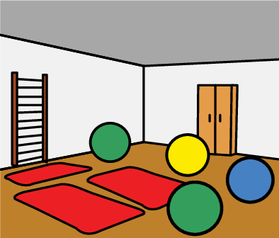

8:20 Sensory Room

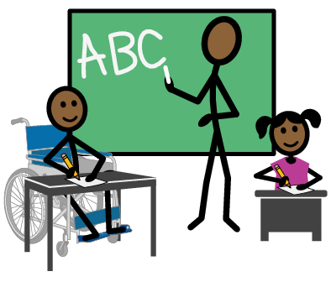

8:35 Morning Meeting



9:10 Reading Group



9:40 Language Group



10:05 Morning Snack

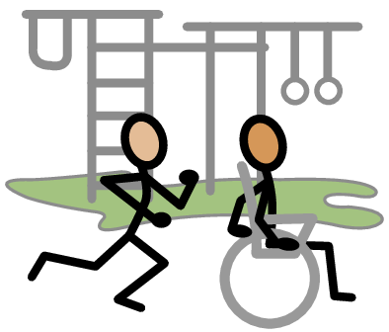

10:15 Recess



10:35 ELA Work / IEP Work

(Rotate between ELA and Math divided up by breaks.)


11:00 Lunch

11:30 ELA Work / IEP Work

(Begin when Lunch is over.
Rotate between ELA and Math divided up by breaks.)

11:45 EDMARK (ELA Interventions)
(IEP Work otherwise)

12:10 Sensory Room

(Go when Edmark is completed.)



12:25 Technology Learning

(If unable to handle technology,
go to previously mastered tasks.)



12:40 Independent Tasks

1:00 Math Work / IEP Work
(Rotate between ELA and Math divided up by breaks.)

1:15 Technology Learning

(If unable to handle technology,
go to previously mastered tasks.)

1:25 Snack



1:30 Specials



2:20 Putty Break

2:30 Recess

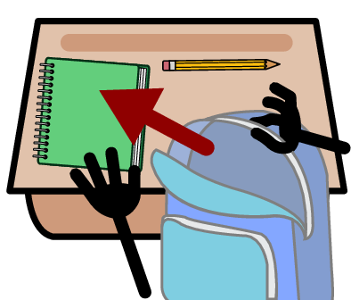

2:45 Clean-Up



2:50 Pack-Up



3:00-3:05 Go Home

