Communication Project: Written Report Part Three

SPED 800: Teaching Language and Communication Skills to Learners with Autism and
Developmental Disabilities

Erica Grindinger
Department of Special Education
University of Kansas

Dr. Deborah Griswold
September 23, 2025

Communication Project: Written Report Part One
Bobby is a 10-year-old fourth grader who recently joined the Intensive Resource Classroom in the Shawnee Mission School District. He qualifies for special education services under the eligibility category of autism. Bobby demonstrates a significant communication need and currently uses an augmentative and alternative communication (AAC) device to support expressive language. His spontaneous communication is limited, and he most often uses the device to select highly preferred items, such as dinosaurs, candy corn, or playdough, although his preferences shift frequently. Bobby has a hands-on and visual learning style; auditory input alone is not effective for him. He responds well to visual supports, structured prompts, and familiar routines, and can follow simple one-step directions.
Bobby presents several strengths that support communication growth. He is motivated to interact with peers and adults and can navigate the basic functions of his AAC device. He participates in classroom routines when supported, and his interests and familiar activities serve as effective motivators. At the same time, Bobby faces significant challenges that limit his independence and social engagement. His expressive communication is largely restricted to repeated selections of favorite icons or protests when demands are placed. He requires consistent modeling and prompting to expand communication beyond requesting, and generalization across settings and partners remains a key area of need. Additionally, he demonstrates frustration when communication breakdowns occur.
Record Review
Information from Bobby’s records and collaboration with his educational team and family provided critical insight into his communication profile. Stakeholders include the speech-language pathologist (SLP), parents, general education teacher, paraeducators, building principal, and members of his previous Individualized Education Program (IEP) team. All parties consistently noted challenges related to motivation, attention, and frustration, particularly when communication demands exceed Bobby’s current skills, or with being denied access to desired items. The prior IEP reflected lower expectations than his current demonstrated abilities, suggesting underperformance in his previous school placement for reasons that remain unclear. Observations from the classroom indicate that Bobby’s receptive language skills are stronger than his expressive skills, consistent with both prior records and current assessment of classroom behavior.
Family input highlighted that Bobby’s behavior at home is generally “excellent,” though he can become vocal during protests or when routines are disrupted. His parents are supportive and open to learning about AAC, though they have differing approaches: the mother tends to be protective, whereas the father is strict and maintains a military-style approach. Bobby had limited exposure to the AAC device at his former school, which likely contributes to his current limited use for communicative functions beyond requesting. These observations underscore the need for interventions that target functional, social, and pragmatic communication skills in multiple contexts.
Target Behavior
The target behavior for this project is clearly defined and observable. During a 30-minute structured instructional activity, Bobby will initiate or respond to social communication interactions using any modality (AAC device, verbal speech, or sign). Countable acts include: (a) starting a conversation, (b) answering a question, or (c) responding after a conversational partner speaks. This operational definition provides clear criteria for identifying and recording communicative behavior consistently across observers.
Child and Family Characteristics
Bobby is primarily a visual and hands-on learner. His motivators include dinosaurs, candy corn, and playdough, although these change frequently. At home, his parents report differing perceptions of his behavior: his mother is protective, and his father maintains a strict, military-style approach. Both parents are supportive and willing to learn about AAC. All aspects of communication remain challenging for him, particularly moving beyond requesting to broader functions such as commenting, initiating, and maintaining interactions (Quill & Stansberry-Brusnahan, 2017).
Teacher and Team Characteristics
The special education teacher has 13 years of experience using AAC and evidence-based practices. The speech language pathologist (SLP) has five years of experience and is eager to collaborate. Paraeducators and other school staff are supportive, and the building culture strongly promotes inclusive practices. Together, the team has committed to consistent implementation of Aided Language Modeling (ALM) across classroom settings (Franzone & Collet-Klingenberg, 2010). The parents are new to AAC but open to learning, and the team plans to support Bobby across all routines and settings to ensure generalization of skills.
Clues Found in IEP
Bobby’s IEP emphasizes increasing functional communication to enhance independence and social engagement. Previous goals were set below his current ability, highlighting a need for updated, appropriately challenging objectives. Current goals focus on expressive and pragmatic communication using AAC, verbal speech, and signs (Sam & AFIRM Team, 2016).
Other Resources Available
Bobby’s program includes multiple resources to support implementation: his dedicated AAC device, visual supports, timers, and reinforcing materials. The team—SLP, special education teacher, paraeducators, and principal—is actively involved in intervention implementation. While Bobby has no siblings, school peers are available as communication partners. These supports provide a strong foundation for fidelity in implementing ALM interventions.
ASCS-2 Assessment Plans
The SLP and special education teacher will collaboratively administer the Assessment of Student Communication Skills-2 (ASCS-2) to gain a comprehensive view of Bobby’s communication profile. All areas of the assessment will be examined, with particular emphasis on expressive language and social/pragmatic skills. Bobby’s stronger receptive language skills will serve as a foundation for growth in other areas. Data from the ASCS-2 will guide intervention planning, support progress monitoring, and ensure alignment of instructional practices with Bobby’s communication needs.
Communication Project: Written Report Two
Selected Evidence-Based Practice (EBP)
The evidence-based practice (EBP) selected for this project is Aided Language Modeling (ALM), supported by the AFIRM module on modeling (AFIRM Team, 2014). ALM is an instructional strategy in which the communication partner uses the learner’s augmentative and alternative communication (AAC) system to model symbol use while speaking. Although this report will not cover the intervention phase, identifying the EBP is important for understanding the baseline conditions in which no modeling or explicit teaching was provided.
Implementation Steps and Timeline
The AFIRM checklist for ALM outlines a sequence of steps for intervention. For this phase of the project, only baseline data were collected, prior to implementation of these steps. The baseline timeline occurred across seven structured sessions in which the following conditions were maintained:
- Identify the target skill/behavior – Expanding communication beyond requesting to include initiating, responding, and commenting. During baseline, this skill was observed without direct teaching or modeling.
- Identify materials and prepare the environment – Bobby’s AAC device, visual supports, and motivating items (dinosaurs, candy corn, playdough) were available, but no modeling of AAC was provided.
- Provide the model – Not applied during baseline. Staff did not use ALM; they only provided opportunities for Bobby to communicate.
- Prompt for learner response – Not applied during baseline. Staff refrained from prompting beyond natural classroom supports.
- Provide reinforcement and feedback – Bobby received general classroom reinforcement (e.g., access to items if requested) but no structured reinforcement tied to social communication was provided.
- Fade prompts gradually – Not applied during baseline.
- Monitor progress and adjust – Only data collection occurred during baseline. No instructional adjustments were made.
This ensured that baseline data represented Bobby’s unassisted communication skills prior to intervention.
Operationally Defined Target Behavior
During a 30-minute structured instructional activity, Bobby was observed for opportunities to initiate or respond to social communication interactions using any modality (AAC device, verbal speech, or sign). Countable acts included: (a) starting a conversation, (b) answering a question, or (c) responding after a conversational partner spoke. This definition allowed for consistent data collection across baseline sessions.
Social Validity
Although intervention results will be presented in Part Three, the baseline data highlighted the social importance of addressing Bobby’s communication needs. His low rate of initiating/responding (8–14% of opportunities) demonstrates a clear gap in functional communication that affects his social participation, independence, and frustration levels. Both his family and educational team have emphasized the significance of improving his social communication, validating the need for targeted intervention.
Instruction (Baseline Conditions)
During baseline, instruction was limited to typical classroom activities. Bobby participated in structured sessions with access to his AAC device and motivating items. However, staff did not provide ALM, systematic prompting, or structured reinforcement. Instructional conditions were intentionally minimal to capture his natural level of communication without intervention supports.
Feedback (Baseline Conditions)
During baseline, Bobby received only natural consequences for his communication. If he requested a preferred item, he sometimes gained access, but no systematic reinforcement, verbal praise, or corrective feedback was applied. This allowed for an authentic measure of his spontaneous communication attempts.
Data Collection Method
A trial-by-trial recording system was used. Each communication opportunity was scored as correct if Bobby responded using AAC, speech, or sign, or incorrect if he did not respond, protested, or used unrelated words/icons. Percentages were calculated by dividing correct responses by the total number of opportunities. This method allowed for quantifiable and replicable baseline measurement.
Sample Baseline Data:
- Session 1: 1/12 opportunities (8%)
- Session 2: 2/15 opportunities (13%)
- Session 3: 1/10 opportunities (10%)
- Session 4: 1/12 opportunities (8%)
- Session 5: 2/15 opportunities (13%)
- Session 6: 1/11 opportunities (9%)
- Session 7: 2/14 opportunities (14%)
These data indicate a stable but low performance pattern.
Adjustments and Modifications
No instructional adjustments or modifications were made during baseline. Sessions were conducted consistently, with the same materials and environment available. This was intentional to ensure the baseline data reflected Bobby’s natural communication skills without influence from intervention strategies.
Communication Project: Written Report Three
Data Collection Process
During the intervention phase, data continued to be collected using the same trial-by-trial recording system employed during baseline. Each communication opportunity was scored as correct if Bobby initiated or responded to social communication using his AAC device, verbal speech, or sign. Incorrect responses were recorded when Bobby did not respond, protested, or used unrelated icons. Sessions occurred daily for approximately 30 minutes during structured instructional periods in the intensive resource classroom.
To ensure fidelity, both the special education teacher and speech-language pathologist (SLP) collected data collaboratively. Interobserver agreement was assessed during 20% of sessions, with results showing over 94% consistency between observers. Consistency of data collection procedures across baseline and intervention phases allowed accurate comparison of trends over time.
Study Results
The results of the intervention indicate that Aided Language Modeling (ALM) was effective in increasing Bobby’s communicative responses and initiations. As documented in Part Two, baseline communication rates were consistently low, ranging between 8% and 14%. These data reflected a stable pattern, confirming the need for a structured intervention to increase functional communication.
Following the introduction of ALM, data were collected across eight structured sessions under identical recording procedures. During the intervention, staff modeled appropriate AAC selections while simultaneously using verbal speech, provided systematic prompts at the beginning of instruction, and gradually faded supports over time. Motivating reinforcers, such as dinosaurs and playdough, were used to maintain engagement, and consistency across adult implementers supported fidelity of instruction.
Intervention Phase Data:
- Session 8: 2/10 opportunities (20%)
- Session 9: 3/12 opportunities (26%)
- Session 10: 3/12 opportunities (26%)
- Session 11: 4/12 opportunities (34%)
- Session 12: 5/12 opportunities (41%)
- Session 13: 6/13 opportunities (48%)
- Session 14: 6/12 opportunities (52%)
- Session 15: 7/12 opportunities (56%)
Bobby’s correct communicative responses increased steadily across intervention sessions, rising from below 15% during baseline to over 50% by the end of the intervention phase. These data demonstrate a clear functional relationship between the introduction of ALM and Bobby’s improved communication skills. His progress reflects a gradual and realistic increase in functional communication, highlighting the effectiveness of ALM in supporting expressive and social language development for learners with autism who use AAC.
Intervention Analysis
Implementation of Aided Language Modeling was conducted with high fidelity by trained instructional staff. The intervention involved adult communication partners modeling symbol selections on Bobby’s AAC device while concurrently speaking the corresponding words aloud. This approach provided repeated exposure to functional communication within natural contexts, allowing Bobby to see and hear modeled language in real time. Systematic prompt fading encouraged independence and reduced his reliance on adult cues over time.
The data demonstrate that ALM was effective in increasing both the frequency and quality of Bobby’s communicative behaviors. As the intervention progressed, Bobby used his AAC device with greater confidence and began to communicate for purposes beyond requesting, such as commenting, responding, and participating in social exchanges. Observable reductions in frustration-related behaviors also coincided with his communication growth, suggesting a positive correlation between increased expressive ability and emotional regulation.
Several factors contributed to these positive outcomes. The use of motivating reinforcers, such as dinosaurs and playdough, maintained Bobby’s engagement during instruction. Consistent implementation of ALM across multiple staff members, including the special education teacher, SLP, and paraprofessionals, promoted generalization and skill retention. Fidelity was maintained through adherence to the AFIRM ALM implementation checklist, ensuring accurate and consistent delivery of the intervention. Gradual fading of prompts allowed Bobby to demonstrate increased independence and self-initiation. Although the results were strong, his progress plateaued near 56%, suggesting that continued intervention and additional generalization opportunities may be necessary to achieve greater independence and higher levels of communication accuracy.
Related Factors
Several contextual factors influenced the success of this intervention. Sessions were conducted in a structured, low-distraction environment that supported effective AAC use. Parental involvement also played a role, as both parents began incorporating limited modeling strategies at home, which likely supported generalization and consistency between settings. Collaborative communication between the teacher, SLP, and paraprofessionals ensured shared understanding of goals and consistent use of instructional strategies. Bobby’s visual learning style and responsiveness to predictable routines positively impacted his participation, though occasional variability in attention and shifting interests sometimes reduced performance consistency.
Generalization
To ensure that Bobby’s communication gains extend beyond the structured instructional setting, several strategies are recommended to promote generalization and maintenance of skills. ALM should be implemented across multiple communication partners, including peers, general education teachers, and family members, to support communication with a wider range of individuals. The intervention should also be embedded in multiple school contexts such as recess, specials, and lunch, allowing Bobby to use communication skills in both academic and social environments. Communication opportunities should be incorporated during preferred and non-preferred tasks to encourage flexibility and spontaneous use of AAC. Continued booster sessions and visual reminders for staff will help maintain the consistency of modeling practices. Finally, ongoing family coaching is recommended to reinforce AAC use at home and in community settings, thereby promoting long-term maintenance and independence.
Data Collection Graph
The graph attached at the end of this report displays Bobby’s baseline and intervention data. The visual representation illustrates a clear increase in correct communicative responses following the introduction of Aided Language Modeling, demonstrating the effectiveness of this evidence-based practice in supporting meaningful communication growth for students with autism who utilize AAC.

References
AFIRM Team. (2014). Modeling. National Professional Development Center on Autism Spectrum Disorder, Frank Porter Graham Child Development Institute, University of North Carolina. https://afirm.fpg.unc.edu/modeling
Franzone, E., & Collet-Klingenberg, L. (2010). Speech generating devices for children and youth with autism spectrum disorders. The University of Wisconsin, The National Professional Development Center on Autism Spectrum Disorders, Waisman Center.
Hume, K., Steinbrenner, J. R., Odom, S. L., Morin, K. L., Nowell, S. W., Tomaszewski, B., Szendrey, S., McIntyre, N. S., Yücesoy-Özkan, S., & Savage, M. N. (2021). Evidence-based practices for children, youth, and young adults with autism: Third generation review. Journal of Autism and Developmental Disorders, 51(11), 4013–4032. https://doi.org/10.1007/s10803-020-04844-2
Individuals with Disabilities Education Act, 20 U.S.C. § 1400 (2004). Individuals with Disabilities Education Act. U.S. Department of Education. https://sites.ed.gov/idea/
McKeithan, G. K., & Marshall, A. (2024). Module two presentation: Pre-linguistic communication [Lecture presented in SPED 800]. University of Kansas, Lawrence, KS.
Ohio Center for Autism and Low Incidence (OCALI). (n.d.). Autism internet modules. https://www.autisminternetmodules.org
Quill, K. A., & Stansberry-Brusnahan, L. L. (2017). ASCS-2 Skills Checklist. In Building communication and social skills for children with autism: Strategies to enhance learning in the classroom (pp. 269–284). Brookes Publishing.
Quill, K. A., & Stansberry-Brusnahan, L. L. (2017). Do-watch-listen-say: Social and communication intervention for autism spectrum disorder (Chapter 3: Assessing social and communication skills, pp. 65–139). Paul H. Brookes Publishing.
Sam, A., & AFIRM Team. (2016). Picture Exchange Communication System (PECS). National Professional Development Center on Autism Spectrum Disorder, FPG Child Development Center, University of North Carolina. http://afirm.fpg.unc.edu/picture-exchange-communication-system

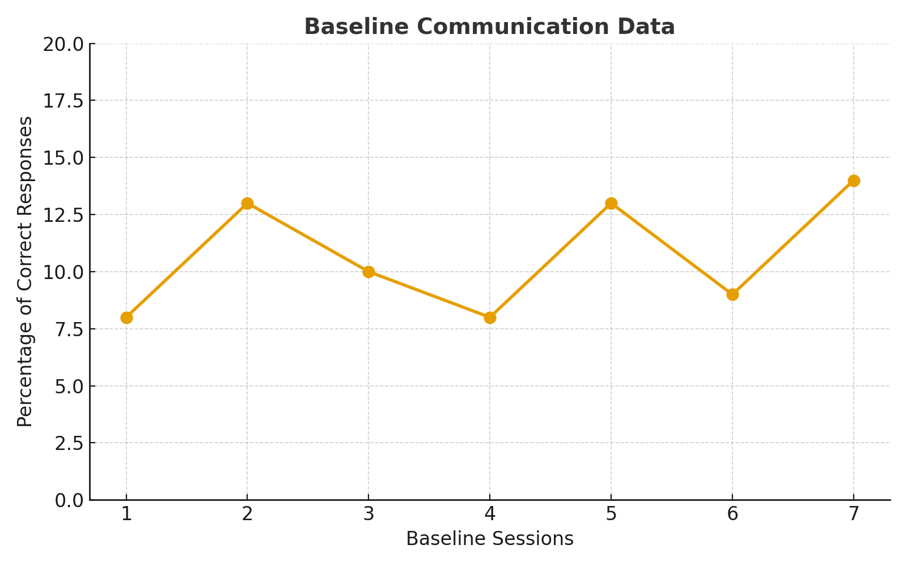
Figure 1
Percentage of correct communicative responses during baseline sessions for Bobby.

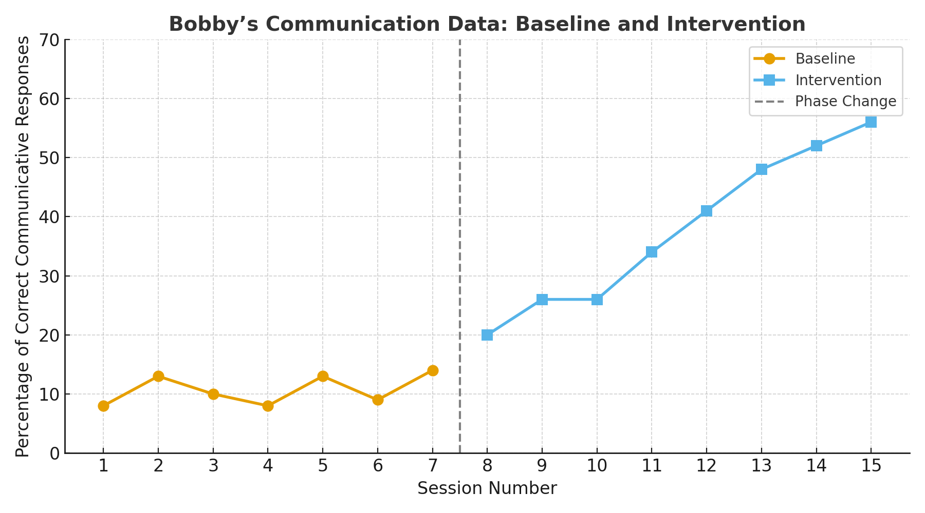
Figure 2
Percentage of correct communicative responses across baseline and intervention sessions for Bobby.

